DESIGN #1

FRONT SIDE:


www.chelm-on-the-med.com

Israel's Laughter Brigade!

BACK SIDE:

LAUGH about Israel,
instead of feeling
SAD, ANGUISHED,
DISHEARTENED,
WORRIED, DISENCHANTED,
UNCOMFORTABLE,
ASHAMED OR ANGRY



DESIGN #2

FRONT SIDE:

www.chelm-on-the-med.com

Israel's Laughter Brigade!

BACK SIDE:

Incredible Snippets of Zany News about Israel
Gleaned from the Hebrew Press
that never make The Washington Post.
Not even The Jerusalem Post…

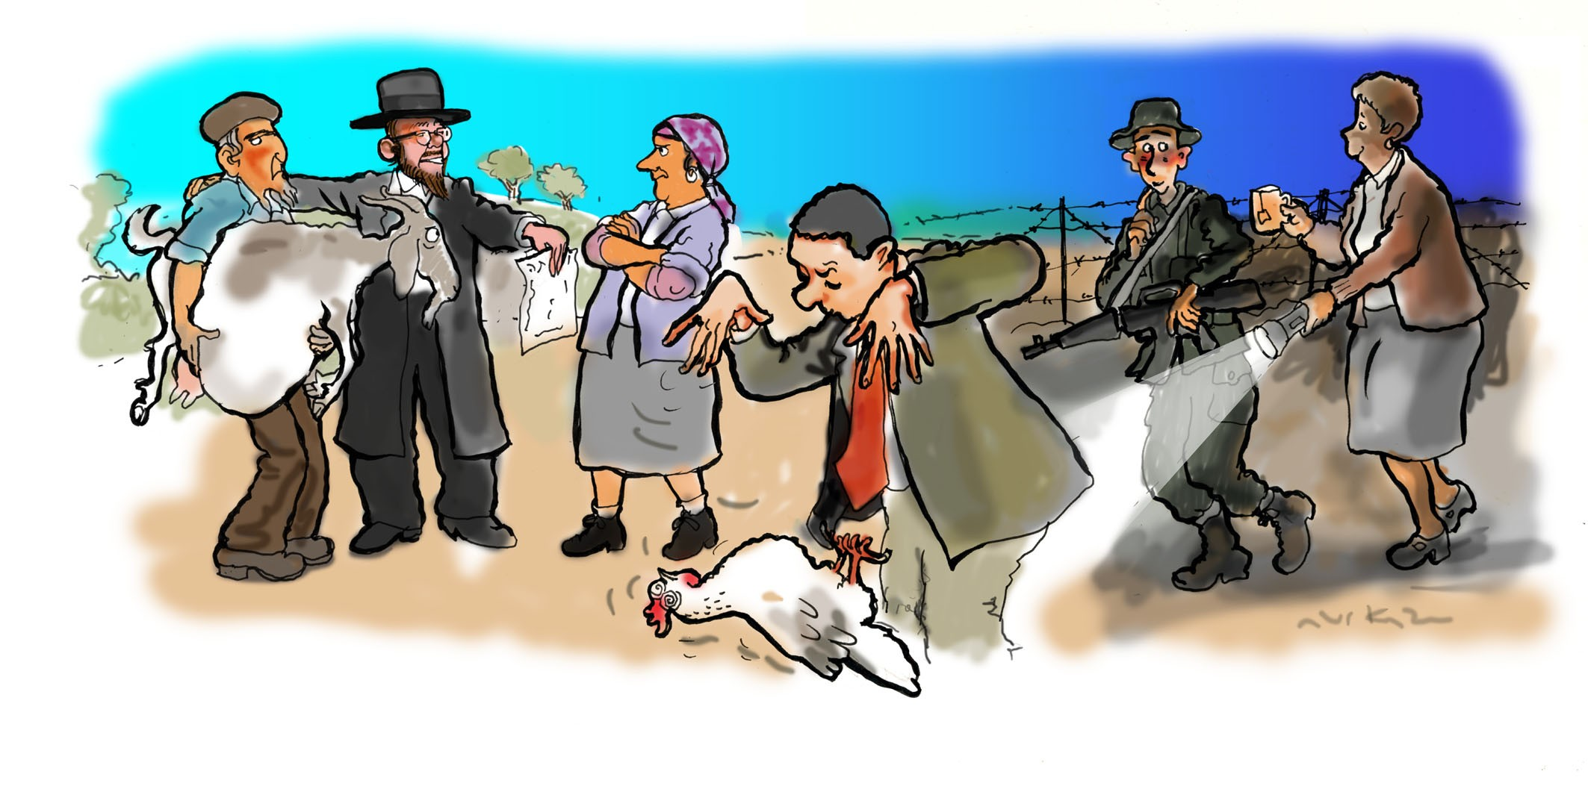
☼ …An Israeli soldier whose ultimate Jewish mother snuck into boot camp every night to accompany her son on guard duty because he was afraid of the dark

☼ …A senior Israeli minister who chose to enchant the press by mesmerizing a chicken, leaving the bird on its back looking like an oversized zapped cockroach

☼ …A divorce settlement that required the divorcee to pay his former spouse one pregnant goat a year for the next 35 years – raising serious questions over ‘who got whose goat’.

